**NEURAL NETWORK DEEP LEARNING**

**ICP 8**

**700746136**

**Haripriya Eddala**

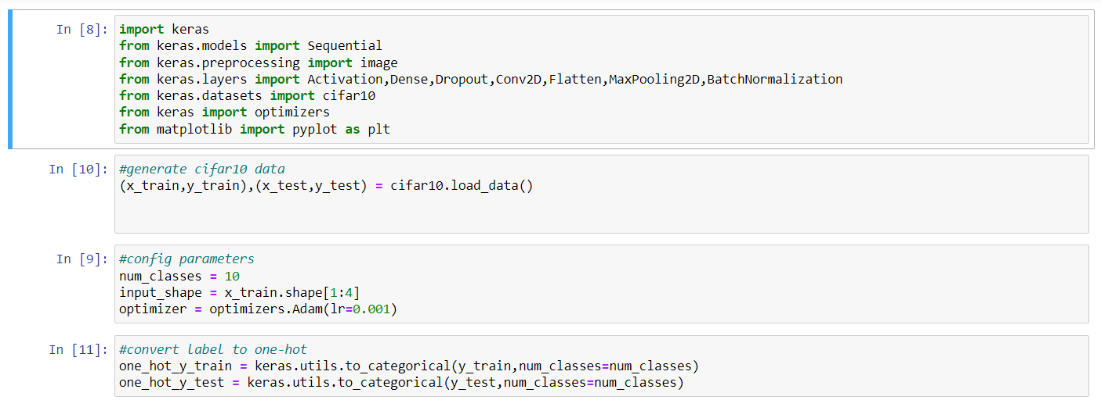

Importing packages and generate cifar10 data, configuring parameters with shape [1:4], number class 10 and optimizers with argument lr = 0.001.

Now labels are converting to one-hot variables.

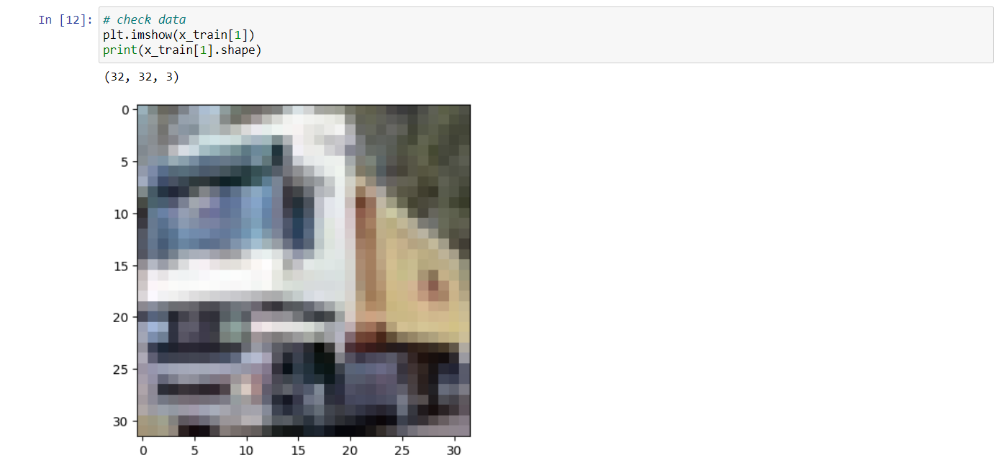

Now checking the data and print it with size 32*32.

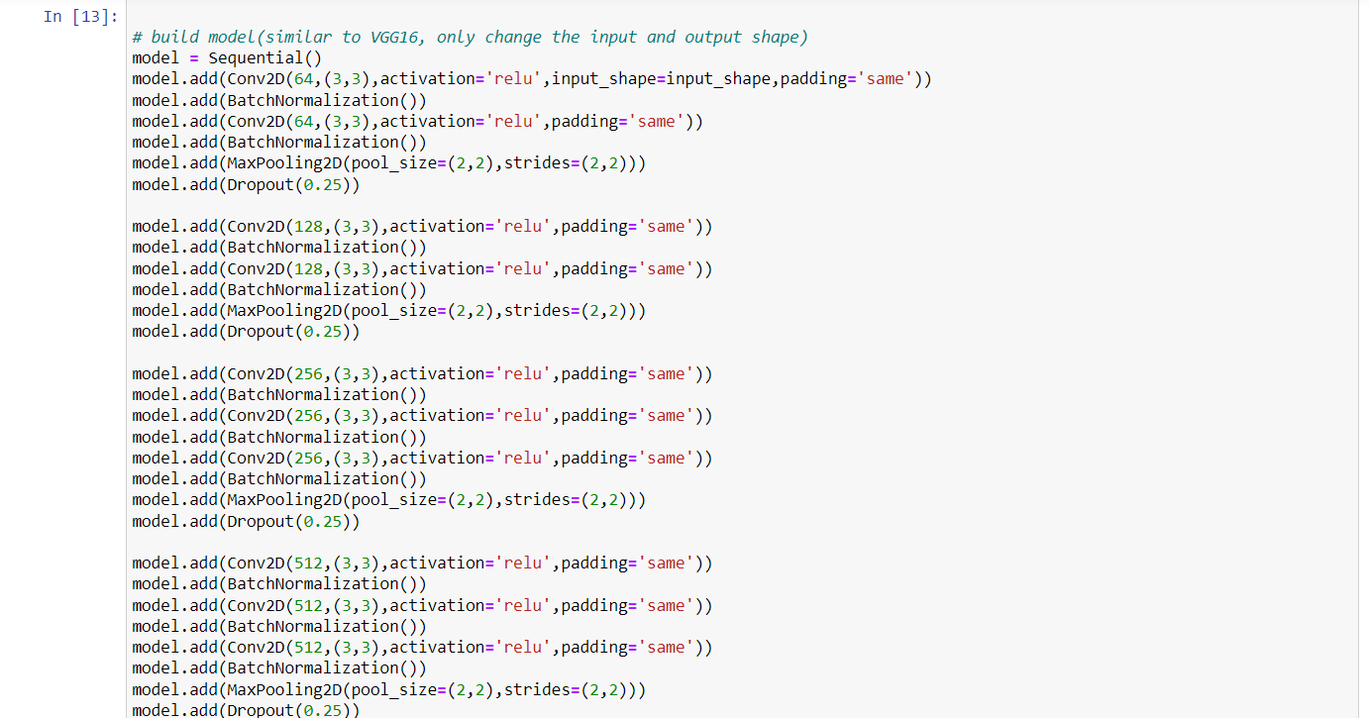

Building the model similar to VGG16 but with only change with input and output shape.

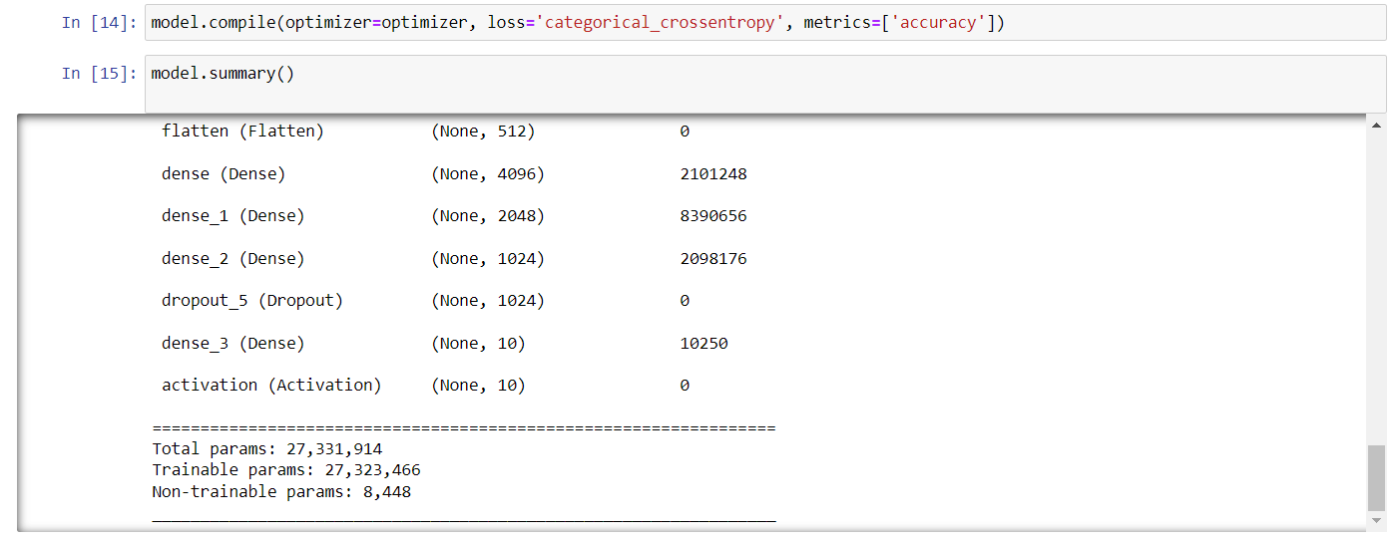

Compiling the model with arguments optimizer, loss and metrics.

After that printing the summary using summary function.

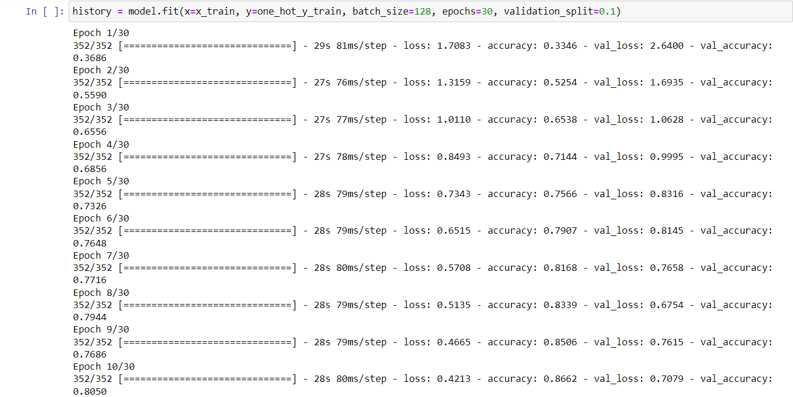

We are using fit function to model training on the data set for 30 epochs and batch size of 128.

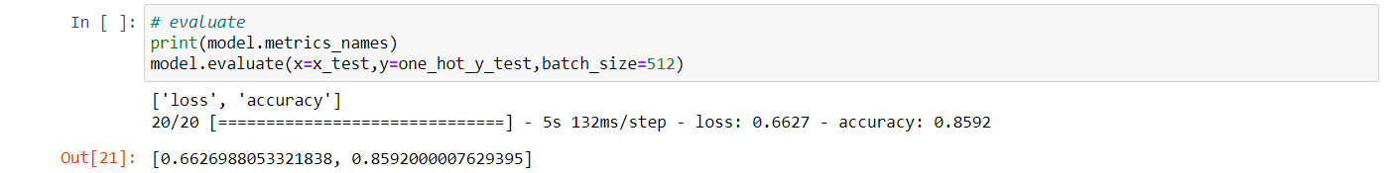

Now, we are printing metrics_name and evaluating with argument batch_size of 512. Now the loss is 0.66269 and accuracy is 0.85920.

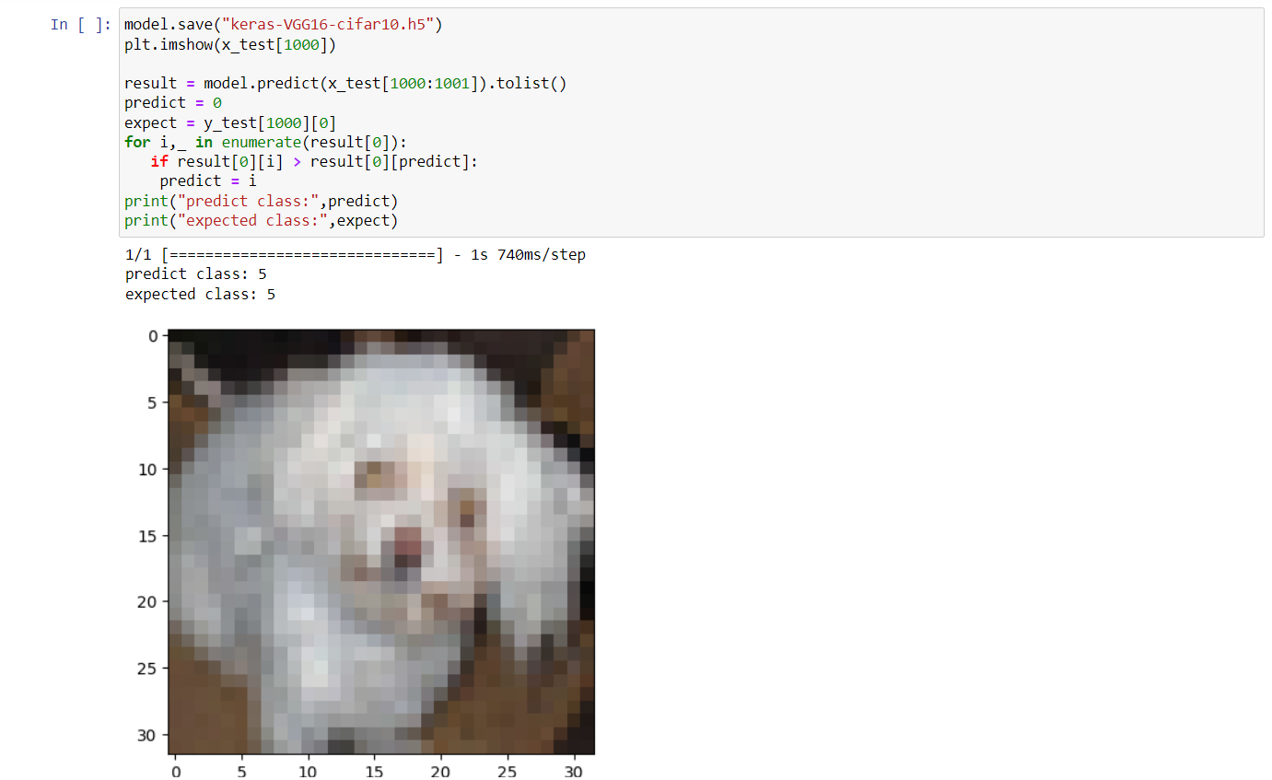

Now we are saving the model using save function. And predicting the model into datatype list. And, printing predict class and expected class.

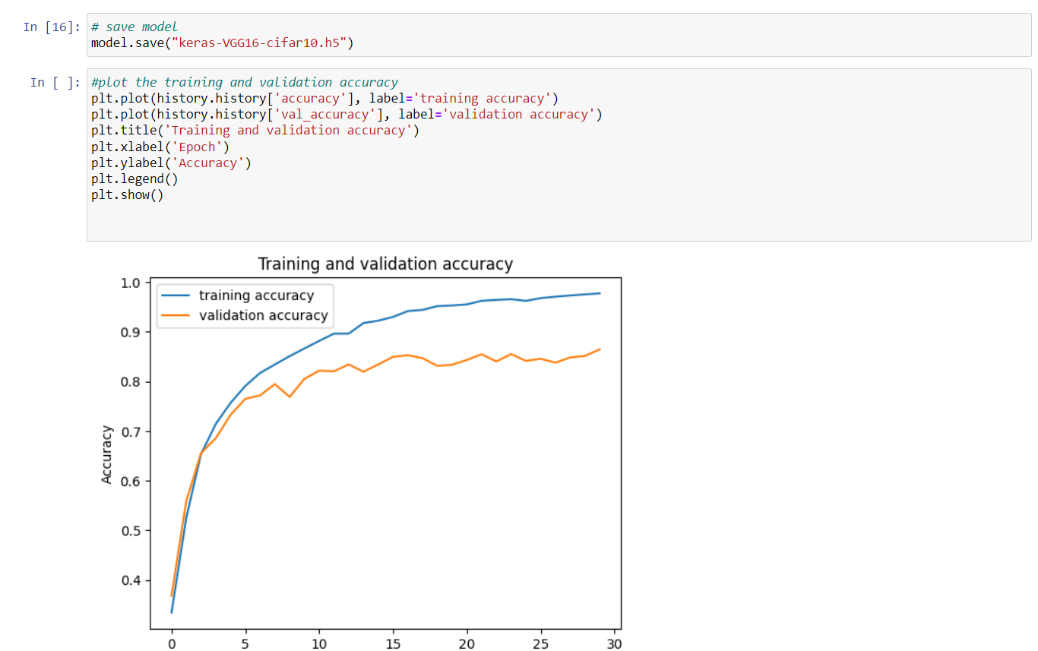

Now saving the model again and printing graph of Training and Validation accuracy.

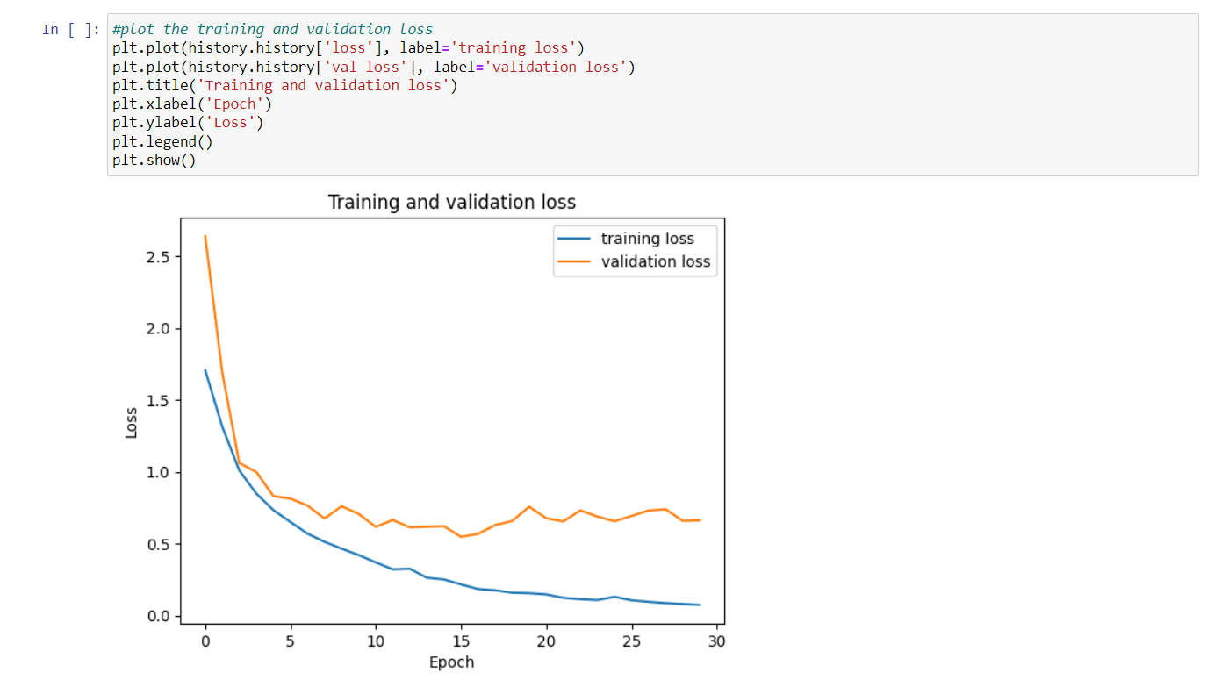

Plotting the training and validation loss.

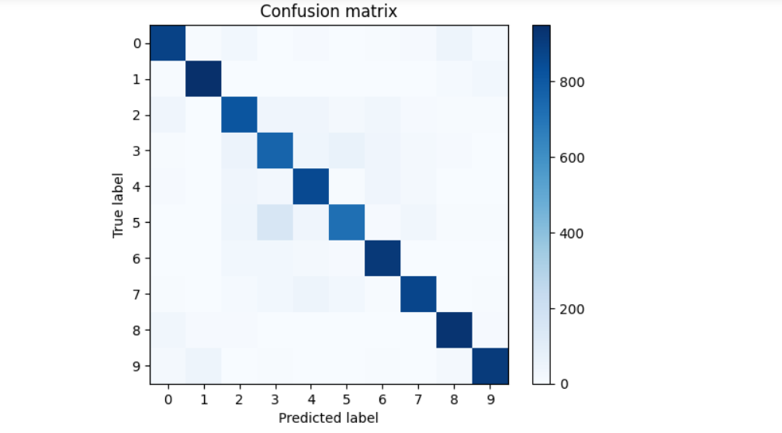

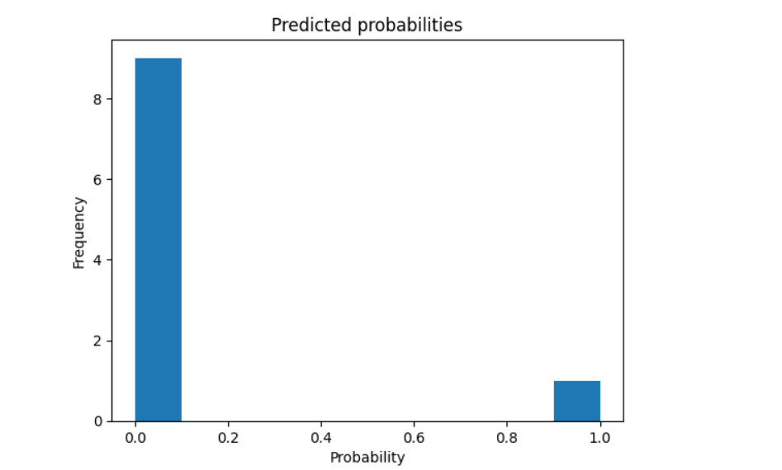

Now printing the confusion matrix and Predicted Probabilities.